

Programming Fundamentals

Student Name :MOMIN HAYAT KHAN

Roll No: S20-0273

Department :BS(Artificial Intelligence)

Batch / Year:SPRING 2020

Lecturer: Mam Misbah

Assignment No: 01

Program No 1:

|  |
| --- |
| #include<iostream>  using namespace std;  int main ( )  {cout << "Welcome to It department";} |

Output:

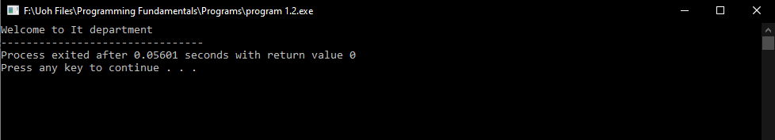

Declare Variables:

Declare 3 Integer Type & 3 float type Variables.

|  |  |
| --- | --- |
| INT | Float |
|  |  |
| int Num1=25 | float Nub1=5.6 |
| int Num2=6 | float Nub2=9.66 |
| int Num3=32 | float Nub3=378.1215 |

ArithmeticOperators:

|  |  |  |
| --- | --- | --- |
| Operators | Name | Example |
| + | Addition | 5+2 |
| - | Subtraction | 5-2 |
| * | Multiplication | 5*2 |
| / | Division | 5/2 |
| % | Modulus | 5%2 |
| ++ | Increment | ++x |
| -- | Decrement | --x |

Precedence:

Operator precedence determines the grouping of terms in an expression.This affects how an expression is evaluated. Certain operators have higher precedence than others; for example, the multiplication operator has higher precedence than the addition operator:

|  |  |  |  |  |  |  |  |  |  |  |  |  |  |  |  |  |  |  |  |  |  |  |  |  |  |  |  |  |  |  |  |  |  |  |  |  |  |  |  |  |  |  |  |  |  |
| --- | --- | --- | --- | --- | --- | --- | --- | --- | --- | --- | --- | --- | --- | --- | --- | --- | --- | --- | --- | --- | --- | --- | --- | --- | --- | --- | --- | --- | --- | --- | --- | --- | --- | --- | --- | --- | --- | --- | --- | --- | --- | --- | --- | --- | --- |
| Category Operator Associativity   |  |  |  | | --- | --- | --- | | Postfix | () [] -> . ++ - - | Left to right | | Unary | + - ! ~ ++ - - (type)* & sizeof | Right to left | | Multiplicative | * / % | Left to right | | Additive | + - | Left to right | | Shift | << >> | Left to right | | Relational | < <= > >= | Left to right | | Equality | == != | Left to right | | Bitwise AND | & | Left to right | | Bitwise XOR | ^ | Left to right | | Bitwise OR | | | Left to right | | Logical AND | && | Left to right | | Logical OR | || | Left to right | | Conditional | ?: | Right to left | | Assignment | = += -= *= /= %=>>= <<= &= ^= |= | Right to left | | Comma | **,** | Left to right | |

Program No 2:

|  |
| --- |
| #include <iostream>  using namespace std;  int main ()  {int a, b;  a = 10;  b = 4;  a = b;  b = 7;  cout << "a :"; cout << a;  cout << " b :"; cout << b;  return 0;} |

Output:

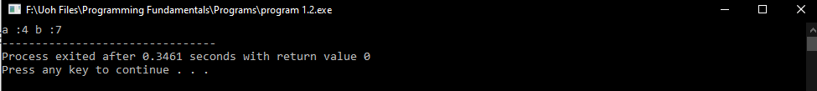

Program No 3:

|  |
| --- |
| #include <iostream>  using namespace std;  int main(){  cout<<"***** *****\n";  cout<<"***** *****\n";  cout<<"***** *****\n";  cout<<"***** *****\n";  cout<<"***** *****\n";  cout<<"***** *****\n";  cout<<"***** *****\n";  cout<<"***** *****\n";  cout<<"***** *****\n";  cout<<"***** *****\n";  cout<<"***** *****\n";  cout<<"###############################\n###############################\n###############################";} |

Output:

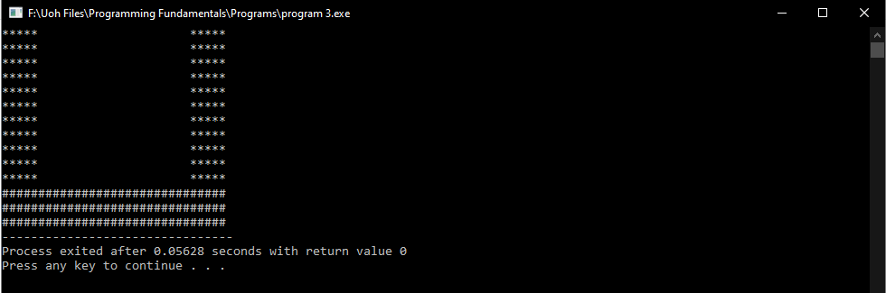

Program No 4 :

|  |
| --- |
| #include <iostream>  using namespace std;  int main()  {  cout<<"$*********************************************$"<<endl;  cout<<"$*********************************************$"<<endl;  cout<<"$*Welcome to *$"<<endl;  cout<<"$* School of Engineering *$"<<endl;  cout<<"$* Haripur. *$"<<endl;  cout<<"$*********************************************$"<<endl;  cout<<"$*********************************************$";} |

Output:

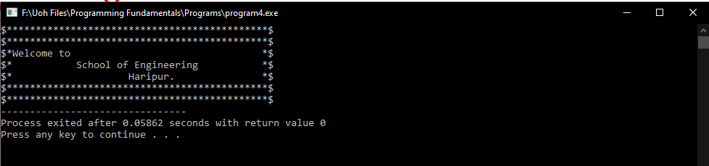

Program 5:

|  |
| --- |
| #include <iostream>  using namespace std;  int main()  {  int r,Area;  cout<<"Lets find the Area of sphere\n";  cout<<"Enter the Radius of sphere =";  cin>>r;  Area= 4*3.1416*r*r;  cout<<"Radius of sphere is = "<<Area;} |

Output:

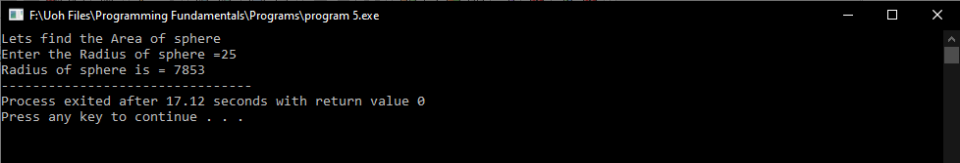

Program 6:

|  |
| --- |
| #include <iostream>  using namespace std;  int main()  { int a;char b;float c;long int d ;bool e ;unsigned int j ;unsigned long k;  cout<<"Size of int a ="<<sizeof(a)<<endl;  cout<<"Size of char b ="<<sizeof(b)<<endl;  cout<<"Size of float c ="<<sizeof(c)<<endl;  cout<<"Size of long int d ="<<sizeof(d)<<endl;  cout<<"Size of bool e ="<<sizeof(e)<<endl;  cout<<"Size of unsiged int j ="<<sizeof(j)<<endl;  cout<<"Size of unsigned long k ="<<sizeof(k)<<endl;  } |

Output:

